* Where are labels or captions for figures in relation to the figure (above the figure, below the figure)?

They are all below the figure.

* Where are captions for tables in relation to the table (above, below)?

The captions are above the tables.

* Are there any tables or figures that do not include a caption?

No. They all have a caption.

* How many sentences are included in each caption? For this one, go through each figure and table and list how many sentences it is. Use bullets for each one in each article.
* First article:

Fig. 1. (1 sentence), Fig. 2. (4 sentences), Fig. 3. (1 sentence), Fig. 4. (2 sentences), Fig. 5. (1 sentence), Fig. 6. (4 sentences), Fig. 7. (1 sentence), Fig. 8. (5 sentence), Fig. 9. (6 sentences), Fig. 10. (5 sentences), Fig. 11. (1 sentence), Fig. 12. (1 sentence), Fig. 13. (4 sentences), Fig. 14. (2 sentences).

TABLE 1 (1 sentence), TABLE 2 (1 sentence), TABLE 3 (1 sentence), TABLE 4 (1 sentence), TABLE 5 (1 sentence), TABLE 6 (1 sentence), TABLE 7 (1 sentence).

* Second article:

Fig. 1. (1 sentence), Fig. 2. (4 sentences), Fig. 3. (1 sentence), Fig. 4. (3 sentences), Fig. 5. (2 sentence), Fig. 6. (1 sentence), Fig. 7. (1 sentence), Fig. 8. (3 sentences), Fig. 9. (1 sentence), Fig. 10. (1 sentences), Fig. 11. (2 sentence), Fig. 12. (1 sentence), Fig. 13. (2 sentences), Fig. 14. (2 sentences), Fig. 15. (1 sentences), Fig. 16. (5 sentences), Fig. 17. (2 sentences), Fig. 18. (1 sentences), Fig. 19. (2 sentences), Fig. 20. (1 sentence), Fig. 21. (2 sentences) Fig. 22. (1 sentence).

TABLE 1 (1 sentence), TABLE 2 (1 sentence), TABLE 3 (1 sentence), TABLE 4 (1 sentence), TABLE 5 (1 sentence), TABLE 6 (1 sentence).

* Third article:

Fig. 1. (1 sentence), Fig. 2. (1 sentence), Fig. 3. (1 sentence), Fig. 4. (2 sentences), Fig. 5. (4 sentences), Fig. 6. (1 sentence), Fig. 7. (1 sentence), Fig. 8. (4 sentences).

TABLE 1 (2 sentences), TABLE 2 (1 sentence), TABLE 3 (1 sentence), TABLE 4 (1 sentence), TABLE 5 (2 sentences).

* What is average number of sentences for table and figure captions?

It is about: 1.75. Almost 2.

* Is the first sentence a complete sentence? Review complete sentences here: <http://www.chompchomp.com/terms/completesentence.htm>

Actually, most of them are complete sentence. Some of them are just noun.

* How many of each figure and table include first sentences that are fragments? What is the ratio?

There are 20 (9+6+5) fragments. The ratio is about 0.32.

* What advice would you give a freshman engineering student about how engineers label figures and tables? Go into detail here.

First of all, when elaborating a picture in one sentence, it is not necessary to tell it in great detail. We need to explain the general content in short words. We don't need to elaborate much on the content of the picture. Try not to use more than two sentences if it is not necessary.

* Insert your own figure into the document and label it correctly using Word’s automatic figure captions. If you aren’t familiar with Word’s automatic captions, try Googling it.

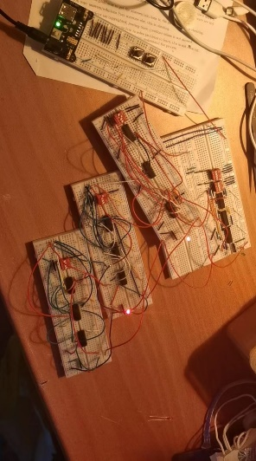

Fig. . Experimental Logic Circuit.